|  |  |
| --- | --- |
| GEN AI LEARNING  **Complete Generative AI Learning – New Year Challenge** | WRITTEN BY: ALOY |

***Day – 4***

**Pre-requisite:**

1. **Create credentials for GROQ Playground (**[**https://console.groq.com/playground**](https://console.groq.com/playground) **)**
2. **Create credentials for PhiData (**[**https://www.phidata.app/**](https://www.phidata.app/) **)**

**Reference agents and tools available in phidata:**

* [**https://docs.phidata.com/introduction**](https://docs.phidata.com/introduction)
* [**https://github.com/phidatahq/phidata/blob/main/**](https://github.com/phidatahq/phidata/blob/main/)

**A list of models is available in GROQ:**

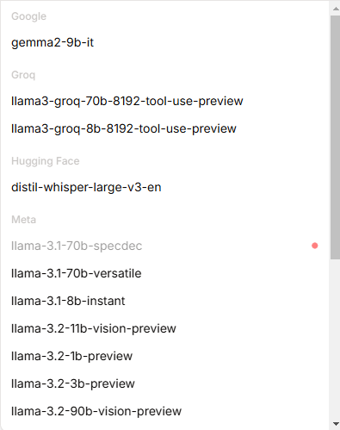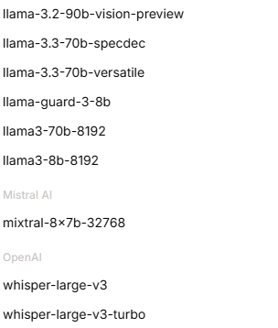

In this document, I will try to explain the basic implementation of Agentic Flow using PhiData. Here are the basic code,



If you want to see your created agent using the PhiData dashboard, you can go through the below URL,

* Step1: Go to <https://www.phidata.app/>
* Step 2: Click on “PLAYGROUND’
* Step 3: Select Endpoint (Your local running code written in ‘**playground.py’** file only)
* Step 4: Choose your agent and chat.

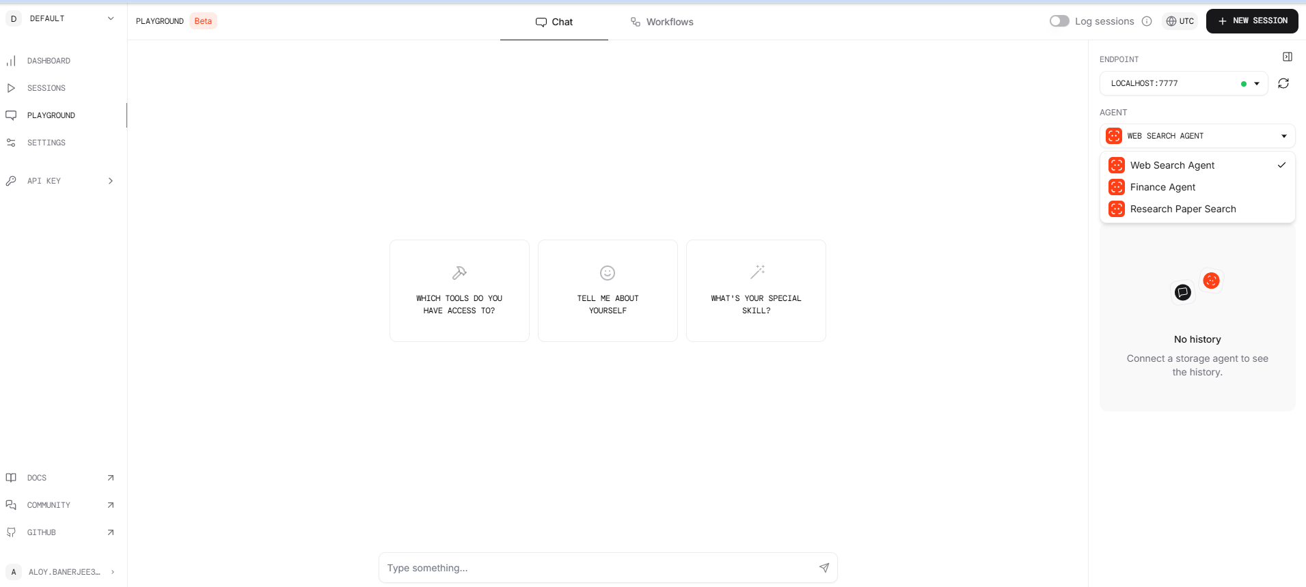

Happy coding..